Creating space for digital work

By: Asher Zafar

***Editor’s Note:*** *In January 2017, the Research and Planning Branch at the Ministry of Advanced Education and Skills Development hosted a Code Day for anyone at the ministry to join and work together to make the Ministry’s work better through digital tools. We asked Asher Zafar, one of the managers in the branch and organizers of the Code Day, as well as Alex Chen, a Policy Analyst, to tell us a little bit about why they decided to take this approach, and what they learned and produced.*

There are few better feelings than when your code runs flawlessly—ok, maybe that’s just us. However, when your job involves policy notes, executive briefings, and communications, switching gears to coding or modelling can be taxing on the brain.

Sometimes we have to get away from the [urgent tasks to get to the important ones](https://www.mindtools.com/pages/article/newHTE_91.htm). We don’t need to tell blog readers how useful digital products can be in bringing better information to users, inside or outside government, with greater efficiency. Developing these products, whether they’re analytical models, web apps or database scripts, is challenging and often requires undisturbed “flow.”

Additionally, individuals with great technical skills on the “business” or “policy” side of an organization often find it challenging to find peers across their organization that can help them find data or share methods.

To help address some of these challenges, our area decided to organize an impromptu Code Day: a full day for public servants to build awesome things with their colleagues, no matter the tool, from Excel to R to Python to Javascript.

To be honest, the path from idea to execution was fairly quick and easy. We sent a witty invitation to a dozen public servants, asked them to spread the word, booked a big room, and planned to order some pizza. Coming up with the fully-fledged idea took about 30 minutes, and getting all the logistics sorted out (attendance list, ordering food, booking rooms, etc.) took another 3-4 hours of work over a few weeks that was handled mostly by our superstar administrator.

There was no curriculum or training, though we posted a few links on Slack and GitHub for those that wanted to focus on self-directed learning. We didn’t do much more than provide a reason for people to focus on cool projects or develop skills.

By 10:30am on Code Day, we had over 15 people from across the ministry deep in their projects and learning from each other—most of whom we didn’t know. It turns out there are plenty of passionate policy analysts who want to bring a new dimension to their work! It didn’t take a big seminar or an expensive training course. We just had to give them space, some links, some guidance, and then leave them alone until they had questions.

People passionate about their work found their peers, and came up with ideas for new projects, tools and ways to access data. We ended the day with an optional show and tell, and a few of the projects included:

* A series of web-based maps that showed various employment and training metrics across the ministry
* Automation of a series of manually generated monthly financial reports that are more accurate and user-friendly
* An interactive, web-based dashboard to compare funding levels and revenue of postsecondary institutions
* A web scraping tool to retrieve data from websites that do not offer it in tidy formats

Beyond these projects, many individuals used the day to learn entirely new frameworks and tools they can bring back to their jobs.

In our case, we subsequently partnered with another division and our colleagues in IT to launch a new server that can be used to share interactive data visualizations and models across our ministry and with our stakeholders. It turns out that there are several other areas across the public service that are already interested in using the same platform.

One manager said her staff members came back from Code Day “jacked up” and motivated. A director from another ministry stopped in, and just launched a larger Code Day of their own.

Most importantly, Code Day made it easier for people to find help and collaborate without having to navigate a somewhat-opaque government structure—it helped business and technical minds “get” each other, and gave people the space and permission to focus deeply on an important project and put aside their smaller, daily tasks for a little while.

One of the things we hear from public servants is that they don’t think their leadership would support such ideas. In our case, our leadership thought it was a great way to surface innovative ideas from across the ministry. While we received support from our leadership, at its core, a Code Day is something that can be done by employees at any level of the organization: all you need is a group of people interested in doing their work collaboratively, and a space and time to let them explore.

We learned a lot from organizing Code Day. For one thing, coding is exhausting. People were mentally checking out at around 3pm. Secondly, coding is often frustrating. We each spent about 30 minutes looking for a bug that turned out to be a single uncapitalized letter in our respective projects, and were assured by the room that is completely normal. The results of coding are cool, but the process isn’t always glamorous.

In the future, we’d probably plan for the day to be a bit shorter (or order coffee). We’re certainly planning to host an event again, and will invite more people, ask others to co-host, and hopefully set up remote video for those that work outside of downtown Toronto.

Overall, we think our first Code Day was a success, and we’ll continue to think of creative ways to bring innovation and a digital-first mindset to the public service.

If you have some ideas on how we do better next time, or have any questions about how to do this in your organization, please do let us know. Comments, ideas, and questions are welcome!

---

## Pull quotes:

*“MAESD Code Day was an amazing opportunity to get out of our silos (physical and mental), and spend a day learning and working with fellow civil servants who are passionate about their work. I didn’t need to come in with a lot of coding expertise to feel that I benefited from the day.”*

~Wilfrid Chan

*“Code day was a fun opportunity to improve my web development skills while getting to know fellow coders. It’s a great way for busy OPSers to learn new skills or find ways to do things more efficiently.”*

~Meagan Cameron

*“It was really great, I had an incredibly happy team coming back after code day, looking forward to the next one, and pumped about the contacts they made during the day.”*

~Christine Hagyard

## Images:

<https://www.flickr.com/photos/geographer700/sets/72157679275798136>

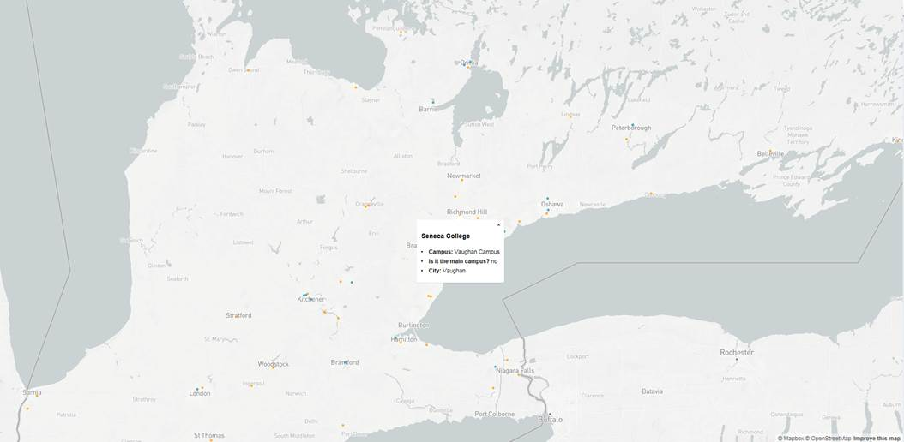

## 

## 

## Medium tags:

<https://medium.com/@asherzafar>

<https://medium.com/@alexaca79>